TM
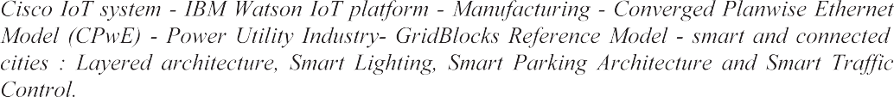

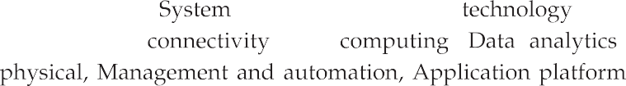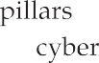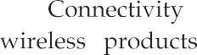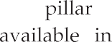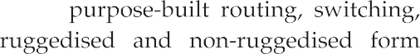

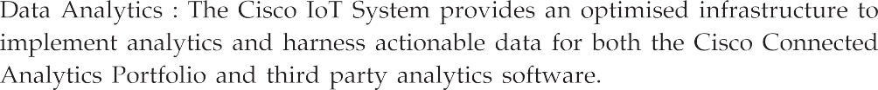
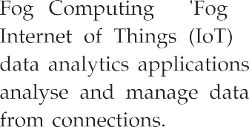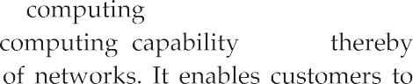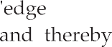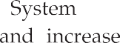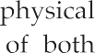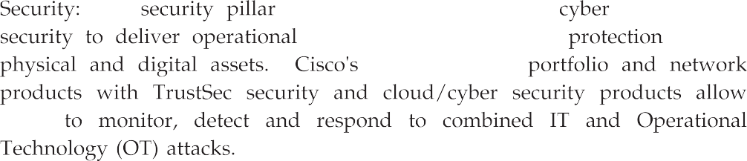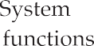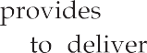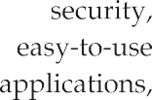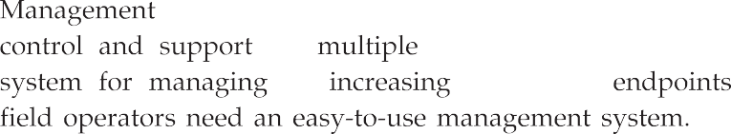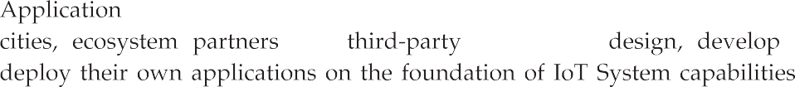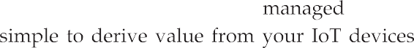

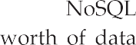

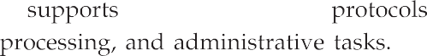
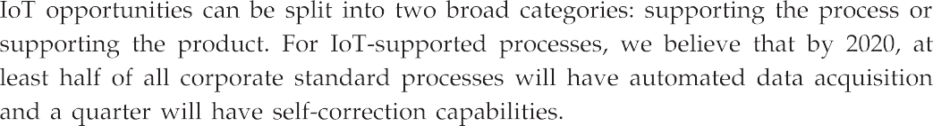
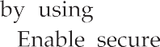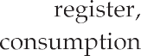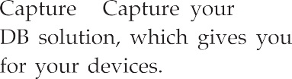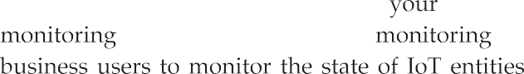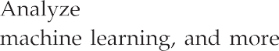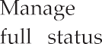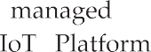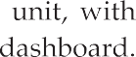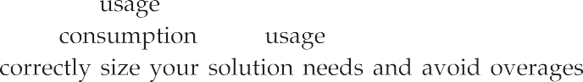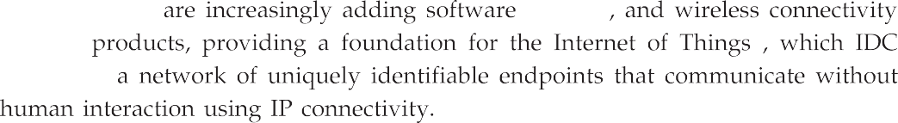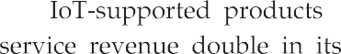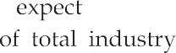

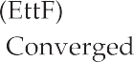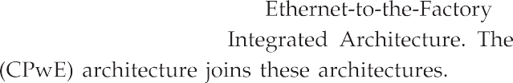

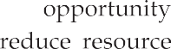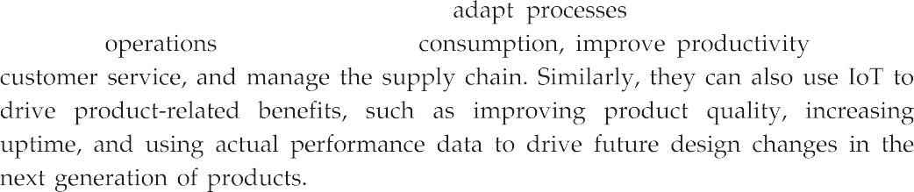
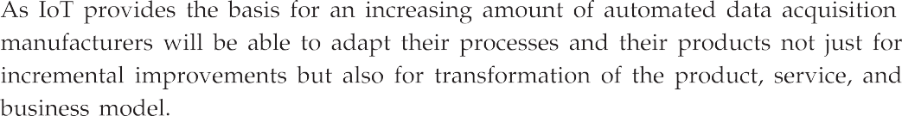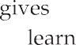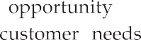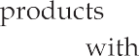

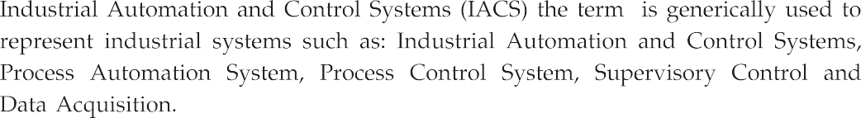
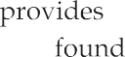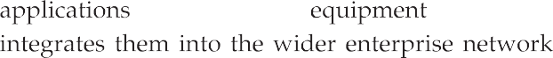

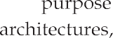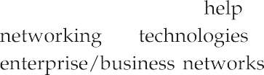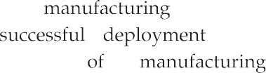

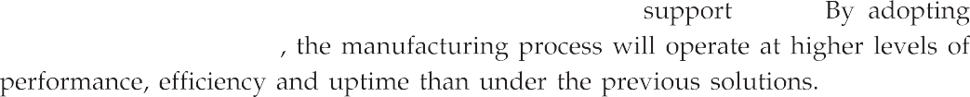

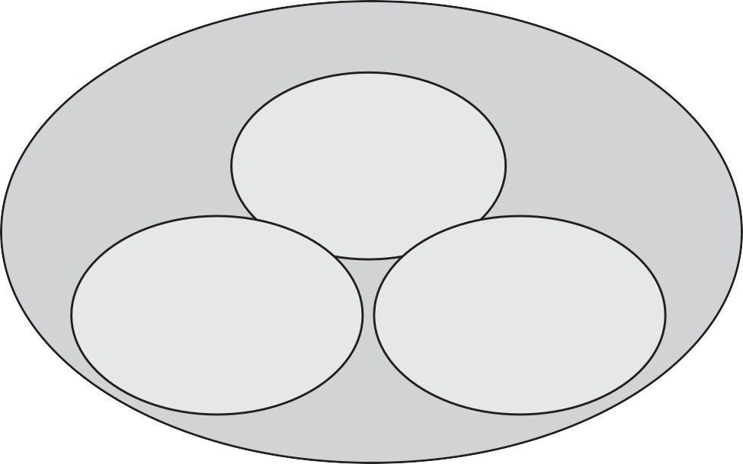
Converged plantwide ethernet

Built on standards Future enabled

Enables secure remote access

Plant specific design and implementation guidance

Industrial EtherNet switches
CIP integration via native ethernet / IP support Enhanced ease of use
innovation platform
Extensive system - level validation testing
United IT and industrial expertise

Ethernet - to - the factory
Framework
Network architecture Security architecture

CISCO
Integrated architecture
FactoryTalk platform Logix control platform Industrial infrastructure

Rockwell automation

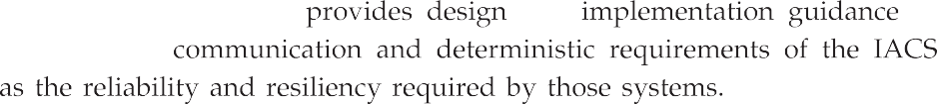

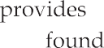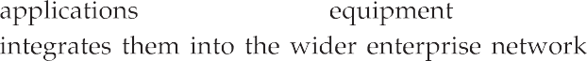

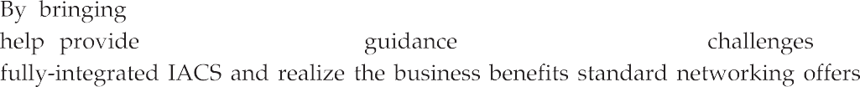

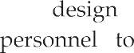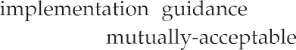

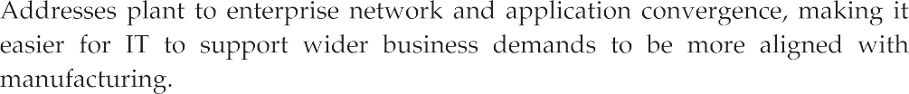
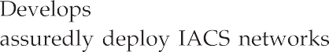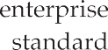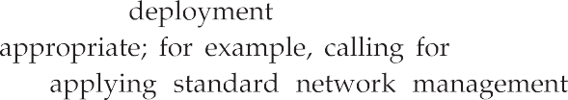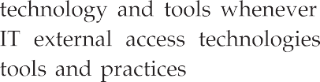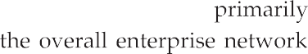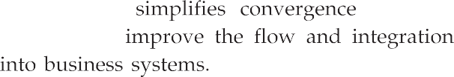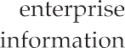

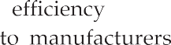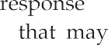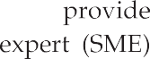

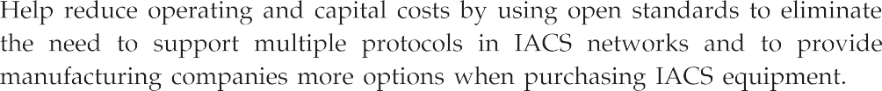
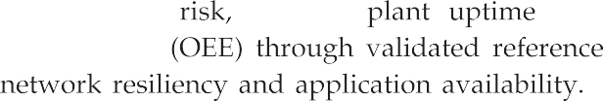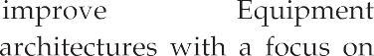

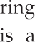
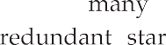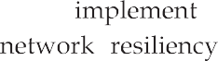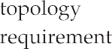

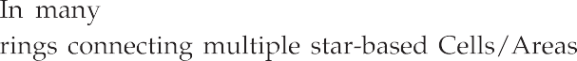

Stacked layer 3 switches
Layer 2 Switch
Human Machine Interface
(HMI)
Programmable Automation Controller (PAC)
Cell/ area zone
Distributed I/O(DIO)

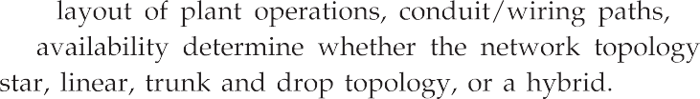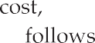

Stacked layer 3 switches
Layer 2 Switch
Human Machine Interface (HMI)
Programmable Automation Controller (PAC)
Distributed I/O(DIO)
Cell/ area zone

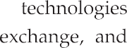

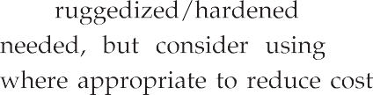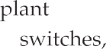
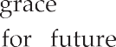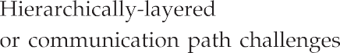

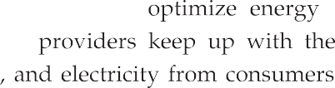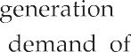

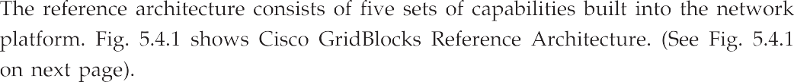
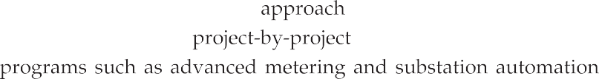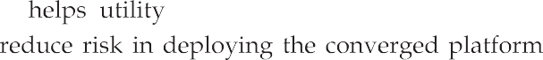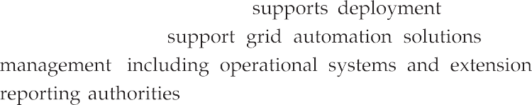

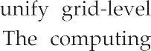
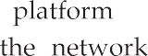

Security interlay
Domain
Network Grid blocks
Mobility/Security
Video/Collaboration
Core

Places
Layered network services
Routing/ Switching network services
Computing platforms framework
Platforms
Vertulization/Cloud
Data center
Data and application framework
Data
Apps

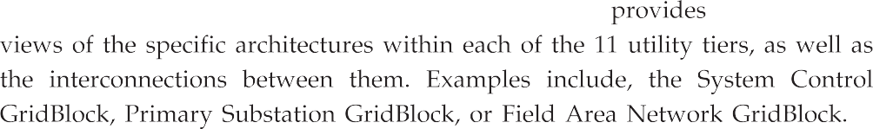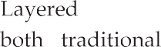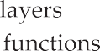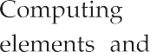

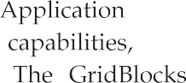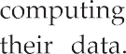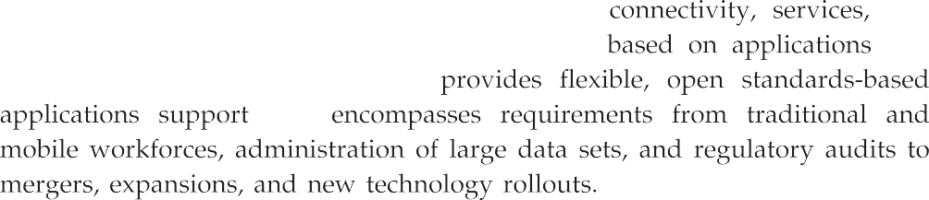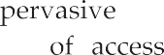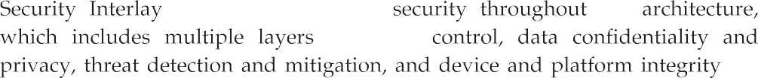

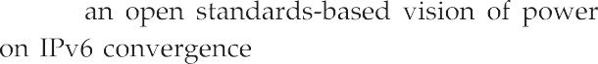

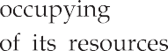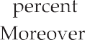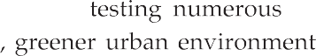

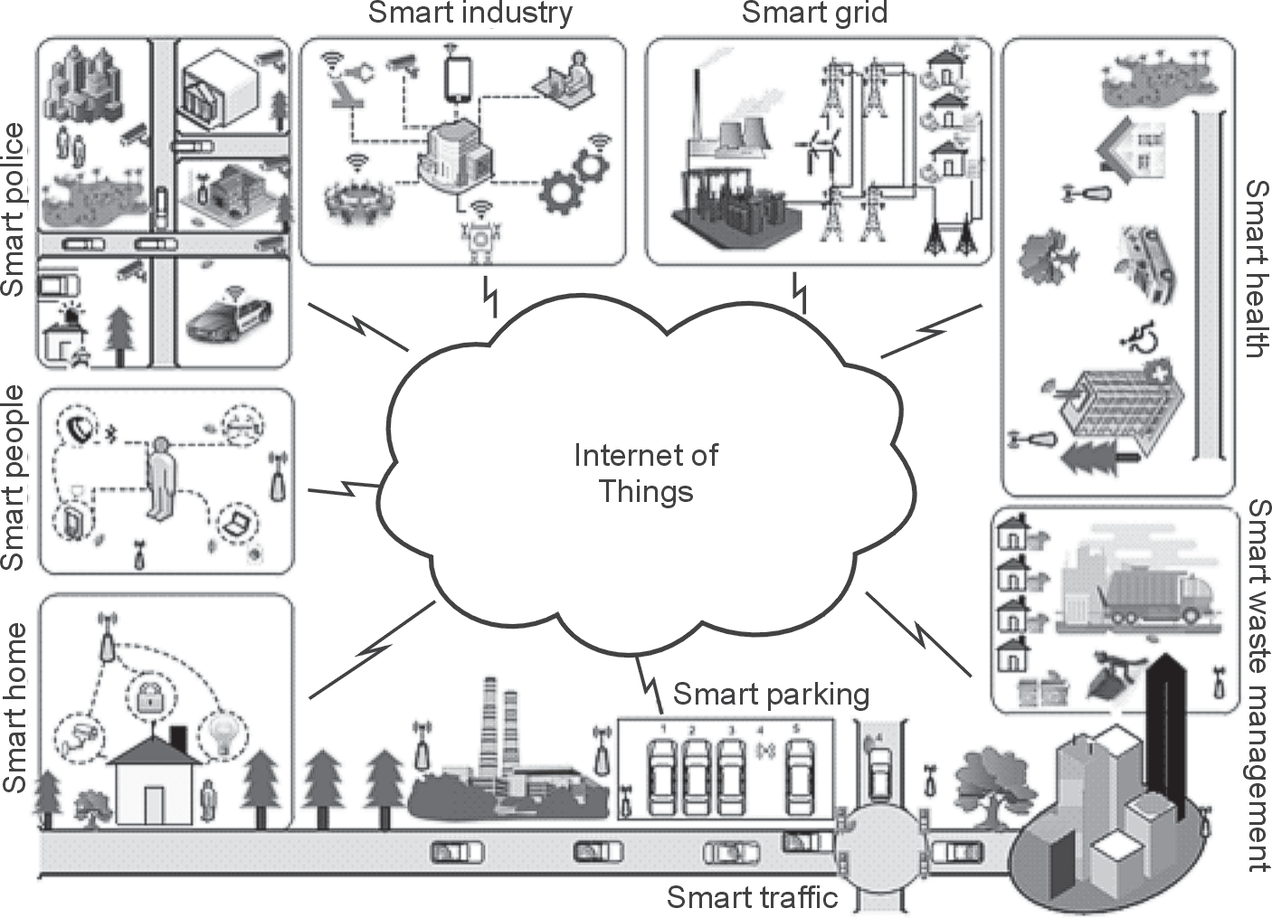

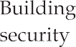
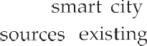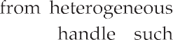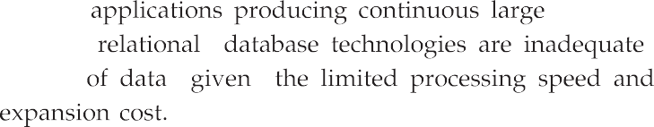

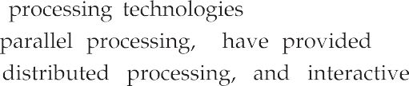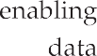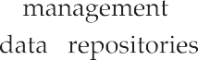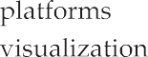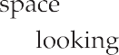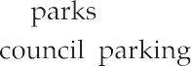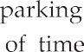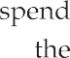

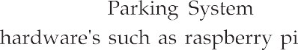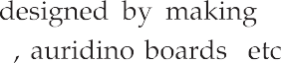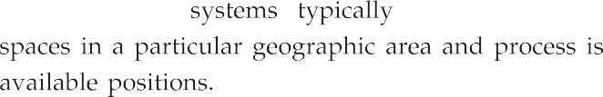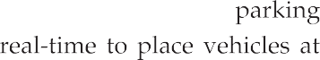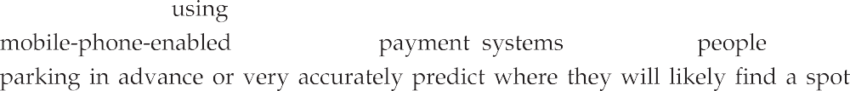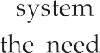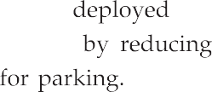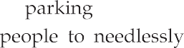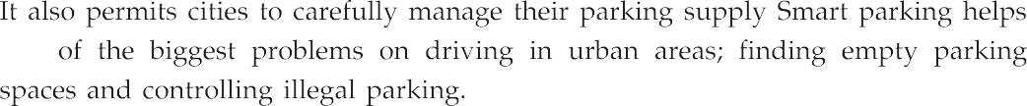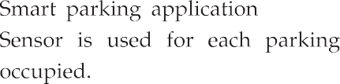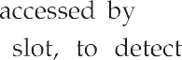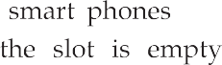

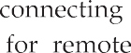
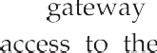

Empty
Check slot
Occupied
Database
Store empty slot
Read sensor
Store occupied slot
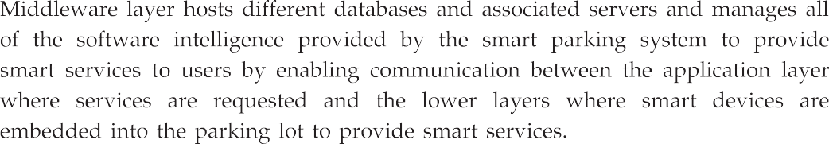
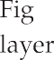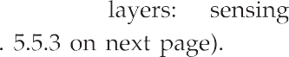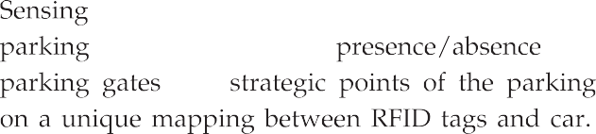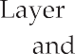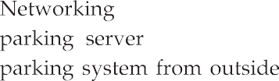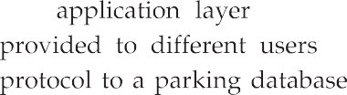

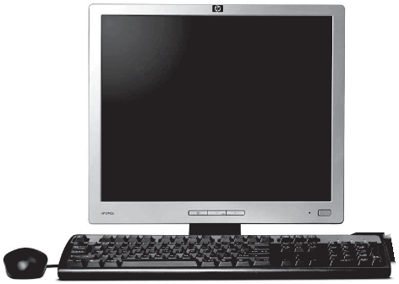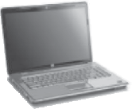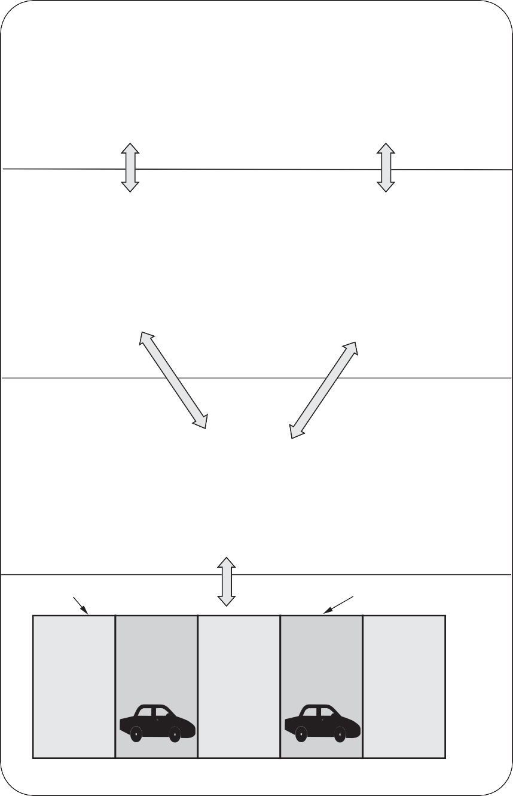Application
Client
Devices
Micro cloud
Web server
hp
Database
Wireless
Free spot
Occupied spot
Parking lot

Middleware

Networking

Sensing

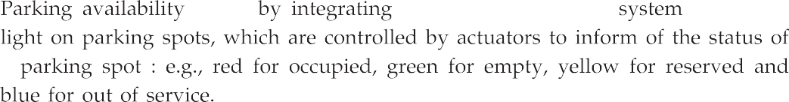

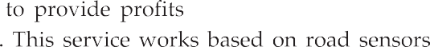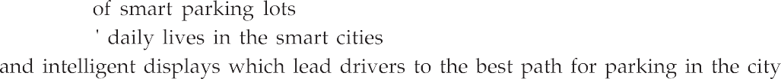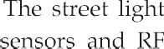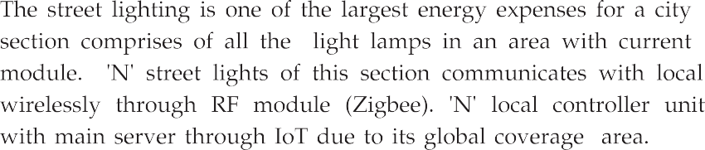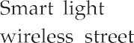

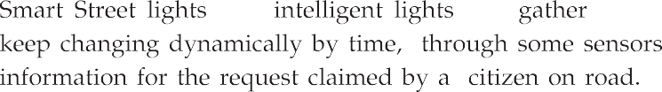

Reliability
Safety
Freedom
Smart roads
Security
Modernity
Comfort

